**International Conference on Sciences, Engineering & Environmental**

**Technology (ICONSEET), 10(15): 26-32, 2023 ISSN 0794-9650**

[www.repcomseet.org](http://www.repcomseet.org)

**Design and Construction of Marking Out Table with Locally Sourced Mild Steel Materials**

Rasheed. O. Azeeza, Opeyemi,B.Ologunye ,Nurudeen A. Azeeza , Oyebode,O.Richard, and ItiolaAdewale

1. *Dept. of Mech. Engineering Technology, Federal Polytechnic Ede, 232102, Nigeria*

E-mail: [engr.roazeez@gmail.com](mailto:engr.roazeez@gmail.com)

**Abstract –**This paper is on the construction of marking out table will locally source mild steel scraps. The study aim atdeveloping marking out table that can perform fairly satisfactory when compare with imported one in term of performance and promote Nigeria dream of increasing local manufacturing. The marking out table was constructed using right design parameters, major components of the table were produced and purchased in some cases. In addition, it deals with the way scientific research works from local fabrication firms can help promote economic development through manufacturing process. In this work, mild steels obtain from local metal markets were used. Mild steel is a ferrous metal that is primarily made from iron and carbon. Its low -price with properties that are suitable for most general engineering applications. The developed marking out table was made with scrap mild steel and other materials. The fabricated marking out table compares well in term of performance with imported commercial types (made from granite or cast iron).

Keywords: Marking out table, mild steel, iron, ferrous metal, iron and carbon.

**Introduction**

The process of transferring a design or shape to a material (such as a workpiece) is known as marking out or layout, and it is regarded as the initial stage of the manufacturing process (Handwiki 2023; Brett2005). Marking out in a manufacturing setting is the process of transferring the dimensions from the plan to the workpiece in order to get it ready for machining or manufacturing. Breit (2005) states that because it is the initial stage of the manufacturing process. It can also aid manufacturing processes such as cutting, bending or shaping(Benjenkins,2017).This is due to the fact that it can aid in the transfer of a pattern, shape, or lines to a material (Benjenkins, 2017). Surface plates, angle plates, scribers, height gauges (also known as scribing blocks), protractors, and other similar instruments are commonly used for marking out.

The unique table that offers a true surface from which to work is known as a marking out table or surface plate.This tool offers a reference plan that can be used to arrange the task and marking tools (pencil, for example) (Mechanical, 2020).Most frequently, this equipment is used to provide the sole control over the dimensions and form of components as well as the essential control over the placement and dimensions of any features (like the holes that components must have) (BET, 1988).Marking ready-cut construction work to be streamlined before it is sent out is another frequent use for table marking (Srisa, 2020).This tool offers areference plan that the task and the marking implements (pencil, for example) are positioned upon.

The way that the marking table (MT) is made varies based on the preferences of the customers. Incertain designs, the table top itself, which holds the material, can be adjusted to rise or fall as needed to give the user a comfortable and appropriate working height (Risa, 2017).Inorder for traditional marking out tables (MT) to function properly, they are constructed from stiff materials.Expondo (2021) lists granite, ceramic, and cast iron as the three materials that are used worldwide for surface plates (also known as marking tables) due to their fineness and smoothness.Kamel (2021) claims that is constructed from closed gain cast iron and undergoes a unique heat treatment to prevent size expansion or contraction after use.Figure 1 depicts a typical marking-out table diagram.

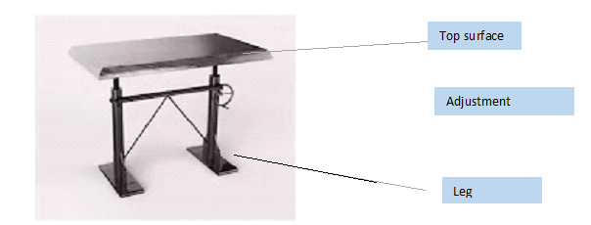

Fig. 1: Typical diagram of a Marking out Table (Jeyapoovan , 2016)

However, because our tables are made of sophisticated materials that are difficult to produce and dangerous, their production is done under specific manufacturing processes (IT,2023).Forexample, high-quality cast iron (Vetres, 2023) is a rare, long-lasting material with a high market value that is used to make mode marking out tables.As a result, there is a great demand for them, and most consumers are prepared to pay a premium to obtain them (KitchenVile,2023). Researchers have created a marking-out tool with inexpensive, effective materials.Using materials found locally, Topp et al. (1993) developed a number of research methodologies for tool design.According to Bankole, et al. (2015), a marking tool structurebased on craft tradition has been developed.The tool's combined data provides a foundation for ongoing tool research and enhancement.

A critical look at standard manufacturing or repair firm in Nigeria reveals that majority of precision tools (including marking out table) used are imported into the country and this is done at high cost. To cater for the increasing demand for low cost marking out tools in developing nations, particularly Nigeria, amidst high cost of importation demand now materials and technology innovation innovations for low cost development of one that can perform comparable with imported ones. However, these studies do not provide the latest research and development framework and modalities that could help towards the design of a low-cost for the small workshop subsector sector, especially, when talking about less developed countries.Whena typical Nigerian manufacturing or repair company is examined closely, it becomes clear that most of the high-priced precision tools used there—including those for marking out tables—are imported.In light of the high cost of importation, there is a growing need for low-cost marking out tools in developing countries, especially Nigeria. Materials and technological innovations are being used to develop low-cost tools that can perform on par with imported ones.However, when it comes to less developed nations in particular, these studies lack the most recent framework and research and development methods that could aid in the creation of a low-cost small workshop subsector.

According to Alexandra et al. (2014), a comprehensive and economical approach considers that the total tool cost for greenhouses is approximately 10-15% of their direct production costs. According to Okoro (2009), most of the equipment needed for vocational trades is accessible at a reasonable cost, which facilitates training and learning even though the tools may be available, they are primarily foreign in nature and expensive to obtain in developed countries. The majority of Nigerian workshop operators depend on imported tools, the cost of which has continued to rise. James (2015) states that as a result of the high cost of tools, citizens are hesitant to enroll in vocational courses. Higher tool costs in certain trades, like carpentry, have encouraged people to select non-technical profession. This work aims to design and develop low cost marking out table with use of local materials.

**2.Methods and Materials**

This work aims to develop a prototype marking out table thatcan help to achieve marking out work in our local workshops at cheaper rate.

**2.1. Design Concept**.

***2.1.1 Sketching and Drawing\***

Following the acquisition of the detailed drawing (Fig. 2), the dimensional components were cut into the appropriate sections using the markings provided in the drawing.Using sold work software, a more advanced version of Autocad drawing software, the marking out table that was to be built was depicted in an isometric drawing.The obtained drawing was highly illustrative, displaying all the required dimensions.This will make it easier to picture what the table will look like once it is developed to its full scale.Figures2 and 3 display the marking out table's components in anexploded view.

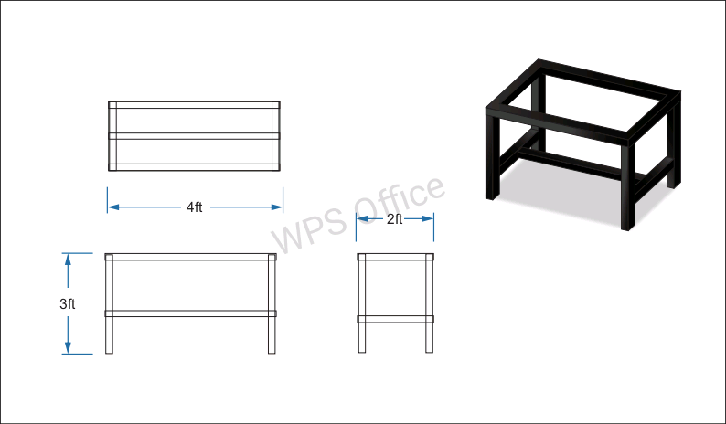

Fig. 2 : Exploded view of the marking out table

**2.3****Material Selection**

Mild steel was a locally sourced material used to fabricate certain parts of the machine.The reason mild steel is used is because its strength, stiffness, and machinability all fall within the parameters of the design.They are also genuinely accessible in local markets and can be obtained with ease at a reasonable price.Most marking out table in current industrial use are derived from close grain cast iron and is given special hear treatment that it does not change its size after use(Mechanical,2021) imposing a limitation to the precision manufacturing industry,which are mostly exist in technological advanced countries.This is given in the cost analysis as shown on the table 1.

**2.4Construction Procedure**

A mild steel metal sheet was used for the construction of table top surface . While the stands and its supports were made from angle iron bars, which formed the main support and of the entire system.Some important procedures for construction this marking out table heightened in this section,

***2.4.1 Marking and the cutting processes***

After the detailed drawing has been obtained (Fig 2),the dimensions shown in it was used to marked out and cuttng the dimensional parts was done into their respective sections. The dimension was presented as follows:The table top (cover) is 4ft x2ft x 1ft length, width and thickness respectively.Dimension of parts for two legs framed at right side of the table are 3 ft length.Drilling of holes were drilled on the metal using a pair of drilling bits and drilling machine. The drilling of holes was based on the detailed drawing.

* + 1. ***Carburization process***

Carburization, which aids in hardening the metal, was carried out between 850 and 1000°C per the recommendation ofthe fire from the crucible furnace was used for this procedure.Carburization, which aids in hardening the metal, was carried out at 850–1000°C in accordance with Koji (2022):ISO 8512-2 (1990)The fire from the crucible furnace was used for this procedure.

***.2.5 Assembly and Finishing process***

Bolting the individual parts together during assembly was done in accordance with the detailed drawing's instructions (Fig 4).Butthe main parts of the marking outthat were bolted and nuts together were the table top and the leg parts.To obtain the framework using the try will appear as.After that, the table's top and other components that were required to complete the piece were correctly nailed together to form the table's frame.

Following the welding of the table as depicted in the drawing (Fig. 4), the marking out table was ground smooth to provide a surface that is easy to spray and point. By removing a small amount of material, the finishing process of grinding is used to tighten tolerance on flat and cylindrical surfaces, improve surface finish, and abrade hard materials. Small fragments of material are removed from the metal part during grinding by rubbing it against an abrasive substance. Similar to sanding, the abrasive material is usually applied to the surface of a wheel or belt. (Kannaiah, 2017).Lastly, a compressor machine equipped with spraying materials was used to spray the constructed table in order to highlight its aesthetic qualities. After letting the table dry, it was prepared for(Kannaiah, 2017).Lastly, a compressor machine equipped with spraying materials was used to spray the constructed table in order to highlight its aesthetic qualities.

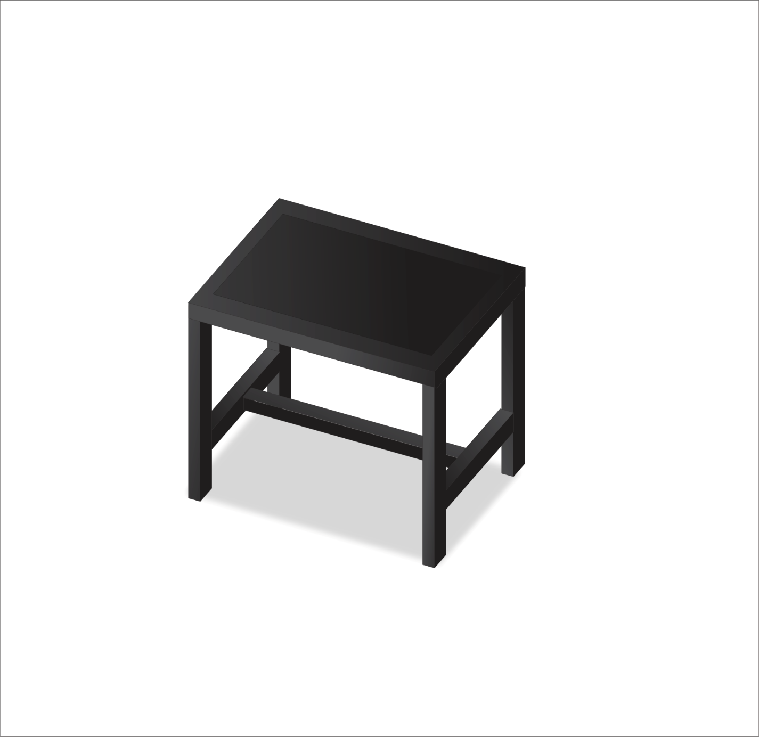

Leg

Top surface

support

Fig. 3 :Isometric Diagram of the 3d Model of the marking out table

**Table 1: Bill of Engineering Measurement and Evaluation (BEME)**

|  |  |  |  |  |
| --- | --- | --- | --- | --- |
| **S/N** | **DESCRIPTION** | **QUTY** | **UNIT RATE (#)** | **COST**  **(#)** |
| 1 | 5 (thickness) by 5mm diameter angle iron | 4 | 7,500 | 30,000 |
| 2 | 5mm metal plate | 1 | 10,000 | 10,000 |
| 3 | Electrode | 4 | 2000 | 6,000 |
| 4 | Saw blade | 4 | 1,500 | 2,000 |
| 5 | Transportation |  |  | 2,000 |
| 6 | Workmanship | - |  | 10,000 |
|  | **TOTAL** |  |  | **60,000** |

**3 Result and Discussions**

A shop floor-sized marking-out table that is straightforward, easy to maintain, and has been developed, built, and tested is depicted in Figure 3 above.To guarantee rigidity and firmness when marking out tasks, the tool is set to remain stationary.Becauseof the device's engineering, it is possible to mark any type of metal workpiece without the need for manual marking or the purchase of pricey marking tables.Because of its smoothness, the device can also be used as a tool for drawing.The local market is a convenient place to obtain these components.

Additionally, marking out tables are employed in a wide range of industries for a variety of purposes, including as a precise foundation for marking, inspection, and layout, as well as for verifying the accuracy of other surfaces and a host of other tasks. The majority of marking and measuring techniques are applicable to a range of materials, and the fundamental tools for efficient marking out are marking marks. In a variety of construction, joinery, and engineering tasks, marking out tools is crucial when generating a template or projecting a pattern or design onto a particular work piece (Sapuan and Harun, 2016). Finally, the table that was built can be compared to a standard table and chair after all the procedures from the literature review were read and additional research was done.Compared to the standard marking out table, which is primarily imported from overseas, the constructed table is 78%.It must also be able to endure any environmental circumstances.

**4. Conclusion and Recommendation**

This work focused on low-cost, easily-sourced materials when designing the locally produced marking out table, and we suggested a straightforward design that can produce a reliable, productive marking out table for use in workshops, job shops, and small manufacturing businesses.This equipment is nearly maintenance-free, works well in both urban and rural settings, and saves money by eliminating the need to order marking tools from overseas.

When creating the low-cost marking out table, we focused on using affordable, easily accessible materials. We also suggested a straightforward design that can assume precise markings in relation to reference lines were obtained for use in the shop floor of a nearby metalworking factory.In developing and underdeveloped nations where it is expensive and difficult to assess all imported types, this equipment can effectively replace imported marking out tables. It also saves money that would otherwise be spent on purchasing any imported equipment and provides an additional means of employing welding technicians.

**References**

Alexandra, C.D. (2014). Integrated design and simulation of chemical process. In Computer Aided Chemical Engineering,2014.

Ashby, M. Vedatu (2017). Materials: Engineering, Science, Processing and Design, Butter worthinemann Publishers.

Bankole I. O.Aban S., Azeez M. Temitayo, Afolabi.S. O. (2015) Computer aided drafting and construction of standard drafting Table for college of engineering Studio in Afe Babalola University, International Journal of Scientific & Engineering Research.6(8): 614-620.<https://doi.org/10.1111/j.1349-7006.2004,tb03205.x.PMID> 15072585.

Basic Engineering Technology (BET) (1988).5-Marking out. *Basic Engineering Technology*, 66-79,1988.[https://doi.org/10.1016/B978-0-434-91949-9.50009-5.](https://doi.org/10.1016/B978-0-434-91949-9.50009-5.103249) [Accessed 21/04/2023].

Benjenkins. (2017). https:// [www.brenjjenkinsmaterialss](http://www.brenjjenkinsmaterialss) processes.weebly.com/marking-out. {accessed 11/05/2023].

Brett, Peter (2005). [Carpentry & Joinery: Job Knowledge](https://books.google.com/books?id=BanuF8GSQaQC). Carpentry & Joinery. Vol. 1 (Illustrated, 3rd ed.). Nelson Thornes. [ISBN](https://en.wikipedia.org/wiki/ISBN_(identifier)) [0748785019](https://en.wikipedia.org/wiki/Special:BookSources/0748785019). Retrieved 2023-02-01

Expondo(2023).Marking out tools :what are types and what shold you buy. https:// <https://www.expondo.co.uk/marking>- out- tool/.[Accessed 21/05/2023

Gutmane, I. Kukle, S.,Zotova,I, and Kisis,A.(2021).Woodworking marking tool structuration based on craft tradition ,*Journal of Cultural Heritage Management and sustainable development, 2021*,https://doi.org/10.1108/JCHMSD-04-2021-0066

Handwiki(2010).Engineering:Markingout.https://https://handwiki.org/wiki/Engineering:Marking_out[Accessed

India Today (IT) (2023). These 10 materials are the most expensive in the world. Retrieved from https://www.indiatoday. in/story

[ISO 8512-2(1990](https://www.iso.org/cms/render/live/en/sites/isoorg/contents/data/standard/01/57/15737.html)) [ISO 8512-2:1990 - Surface plates — Part 2: Granite](https://www.iso.org/standard/15737.html) www.iso.org/standard/15737.html

James,A.J. (2015). Challenge and Prospect s of Vocational and Technical Education:Most important Tool for enhancement and innovations in higher education in Nigeria, Journal *of Research Development,24*(1), July 2015 ,1-8.

Kamel,D. (2021). *Marking out tool s in workshop: types &uses*. <https://www.mechanical.com/methodogy/markingtools(marking>

Koyi,O.(2022). Carburizing of steel.Encclopedia of Materials:Metals and Alloys, 2,2022:161-172. doi:10.1016/B978-0-08-12-803581-8.121277

MEM12006C.https/www.Training.gov.au/trainingdetails/MEM12006C. [Accessed 11/06/2023]. 21/10/2023].

Mechanical (2023). Marking Tools (Marking Tools) in workshop; types and uses . Retrieved from <https://www.mechnical.com/2021/02.>

Okoro,C. F. (1993). *Funding Vocational and Technical Education to meet Future Manpower Need of Development in Nigeria*.Nsukka: Nigeria Vocational Education.Haskab. pp. 119-123

Raju, B.V. (2020). Engineering Workshop Manual, Institute of Technology Narsapur, Medak, Vishnu Universal Learning Publishers.

Risa S. (2017). Marking Table. https:// www.srisa.no/merkebord [Accessed 21/10/2023].

Vetres(2023). Marking out Techniques. <https://www.vetres.net.au/product>. [Accessed 11/06/2023]. 21/10/2023].